LPE2504 CREATIVE WRITING SKILLS
SEMESTER 1 – 2025/2026
LECTURE NOTES 2 – WEEK 4

WEEK 4

HELLO-GOODBYE POEM

A Hello-Goodbye is a type of poem that has a Hello-Goodbye stem (word or phrase at the beginning of each line). There is no set number of stanzas, but each stanza has two lines. The poems may be based on diverse themes which may include social issues, personal likes or dislikes, relationships, nature, or the environment.

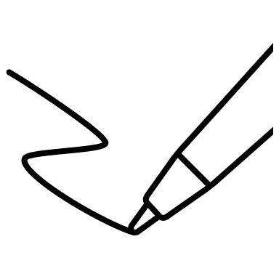
Activity 1

Poem 1

Instructions
Read the poem below and answer the following questions.
- What is the poem all about?
- What do you notice about the structure?
- What is noticeable about the way the lines are constructed in each stanza?
- Do the chosen words reflect a certain theme, idea, or message?

Hello, Spring! Goodbye, Winter
by Tracie Padal

Hello, crisp new umbrella that catches falling sky!
Goodbye, tired old snow boots that leak and sag.

Hello, splashy puddles that glitter in sunshine!
Goodbye, bulky sweaters that make me itch.

Hello, warm mud that squishes between my toes!
Goodbye, icicles that shiver and drip.

Hello, spring!
Goodbye, winter.

https://www.palatinelibrary.org/sites/default/files/2021-02/Teacher%20Guide--Hello_Goodbye%20Poem.pdf

Poem 2

Instructions
Read the poem below and answer the following questions.
- What is the poem all about?
- What do you notice about the structure?
- What is noticeable about the words used in each stanza?
- Do the chosen words reflect a certain theme, idea, or message?

Hello sunshine!
Goodbye rain!

Hello shopping mall!
Goodbye salary!

Hello chocolate!
Goodbye teeth!

Hello coffee!
Goodbye sleep!

Hello peace!
Goodbye war!

Hello smoking!
Goodbye health!

Hello paper!
Goodbye trees!

(Unknown Author)

Notes

- A Hello-Goodbye poem allows the writer to write things from different perspectives.
- Some would see opportunities while others would see difficulties.
- The poem is aurally pleasing when sounded as there is a repetition of the stem Hello and Goodbye.
- There is also the idea of opposites within each stanza.


Discussion

- How different is a Hello-Goodbye poem with other poems you have read before?

- How do you feel about the way the Hello-Goodbye poem is written?

Activity 2

Instructions
Fill in the blanks to complete the following Hello-Goodbye poems.

Poem (i)

Untitled

Hello honey!
Goodbye ________

Hello cat!
Goodbye ________

Hello absence!
Goodbye ________

Hello thrill!
Goodbye ________

Hello noose!
Goodbye ________

Hello forward!
Goodbye ________

Hello destruction!
Goodbye ________

Hello night!
Goodbye ________

Poem (ii)

Mid-semester break starts!

Hello _________________
Goodbye _________________
Hello _________________
Goodbye _________________
Hello _________________
Goodbye _________________
Hello _________________
Goodbye _________________
Hello _________________
Goodbye _________________

Activity 3

Part 1
- Get into pairs.
- Choose one of the topics below and write a 5-stanza Hello-Goodbye Poem.
- Include the use of literary devices in your poem. Underline the literary devices.

Suggested topics
School/university life | Home/Hostel | Change of seasons | Climate Change | Personality
Childhood/adulthood | Sports | Love | Friends | Animals

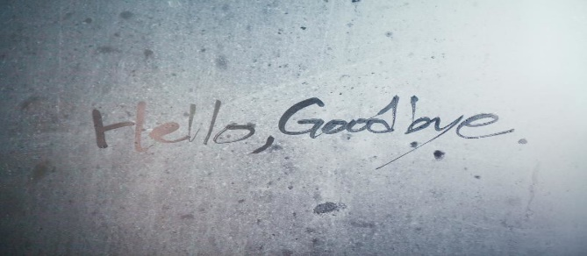

This Photo by Unknown Author is licensed under CC BY-SA-NC

Part 2

- Read out and perform your Hello-Goodbye Poem from Part 1.
- Receive feedback or comment on your work.

Suggested general feedback guide:
- What is the poem about?
- Are the words related to the theme/idea/message?
- Do the words selected in each stanza contradict each other?
- Structure: Does the poem follow the required structure? (i.e., 5-stanza Hello-Goodbye Poem).

